Matthew Marzano
University of Pittsburgh
CMPINF 2130: The Art of Data Visualization
April 25, 2025

Rooted in Equity: Mapping Pittsburgh’s Urban Tree Benefits and Opportunities

Narrative:
Urban trees do more than make sidewalks look beautiful, they function as critical infrastructure, offering environmental and economic benefits such as stormwater mitigation, air purification, energy savings, and enhanced livability. Yet, these advantages aren't distributed equitably. This data story examines how tree-related benefits vary across Pittsburgh neighborhoods, aiming to equip local decision-makers, planners, and residents with actionable insights to strategically target tree planting and maintenance efforts.
The data was utilized from the Western Pennsylvania Regional Data Center’s Street tree inventory, featuring tree location, species, size, condition, and quantified benefits like energy and air quality impacts. Visualizing this data with Tableau Public, I created five complementary, interactive visuals: a geographic benefit map, species diversity bar chart, electricity savings word cloud, tree condition bar chart, and neighborhood equity scatter plot. Each visual addresses a distinct aspect of urban forestry.
The geographic benefit map illustrates the uneven distribution of resources, highlighting neighborhoods such as Squirrel Hill, Shadyside, and Point Breeze that benefit from dense tree coverage. In contrast, Downtown, the Strip District, and certain parts of the North Side have significantly fewer trees and reap lower benefits. Established neighborhoods often feature large, mature trees, which disproportionately enhance air quality and stormwater management. Economic advantages, including increased property values, further exacerbate inequities, as wealthier areas continue to benefit the most. This insight emphasizes the potential impact of targeted planting initiatives in underserved areas to achieve equitable urban forestry benefits.
The second visualization, a species diversity bar chart, gives an overview of tree species across the city. Common species such as Norway Maple, Callery Pear, and London Plane Tree represent a significant portion of the urban forest. While planting hardy and fast-growing trees is beneficial in some ways, relying heavily on only a few species increases the risk of widespread damage if pests or diseases target these common trees. Conversely, having a variety of less common species, even in smaller numbers, helps strengthen biodiversity and provides ecological stability, reducing the chance of extensive tree loss. This visualization highlights the importance of increasing species diversity in future urban tree planting efforts to enhance resilience and ensure long-term ecosystem benefits.
The third visualization, an Electricity Savings Word Cloud, highlights the tangible economic outcome of reduced electricity costs from tree shade and cooling. Neighborhood names appear sized proportionally to their electricity savings. Larger, darker names such as Squirrel Hill North and Shadyside signify significant energy cost reductions, while smaller names like Homewood North reflect minimal savings. Beyond cost reduction, these savings help mitigate urban heat islands, directly benefiting vulnerable populations by lowering heat-related health risks. This visualization distinctly captures the economic and public health divide associated with tree canopy distribution, reinforcing the need for equitable tree planting.
The Tree Condition Bar Chart categorizes tree health into Excellent, Good, Poor, and Dead. While most trees are healthy, a notable proportion is in poor or dead condition. Poorly conditioned trees pose safety risks and potential liabilities, increasing municipal costs due to emergency removals and storm damage. Proactively managing these at-risk trees not only preserves the environmental benefits of the canopy but also helps the city avoid costly emergency removals, storm-related damage, and potential liability lawsuits. Investing in early maintenance programs can save municipalities money over time compared to reactive tree removals after failures. This insight highlights the importance of pursuing both new tree planting and proactive maintenance programs to protect and strengthen the overall health and benefits of Pittsburgh’s urban forest.
Finally, the Neighborhood Equity Comparison Scatter Plot strategically evaluates urban forestry gaps by comparing average overall benefit per tree against tree quantity per neighborhood. Neighborhoods like Squirrel Hill North perform strongly in both tree count and per-tree benefits, while areas such as Homewood South show lower numbers in both categories, which is a potentially concerning combination. The per-tree benefit, averaging around $115 annually, reflects measurable ecosystem services such as air purification, stormwater mitigation, energy savings, and CO₂ sequestration, all of which would otherwise require significant municipal investment. Observing this visualization, we will be able to understand priority areas for resource allocation, which would eventually lead to guiding equitable reforestation strategies.
Our data story reveals that Pittsburgh's urban forest provides substantial environmental and economic benefits, but these advantages are distributed unequally across the city. Neighborhoods with abundant, healthy, and diverse tree populations receive significantly greater value in terms of air quality improvement, stormwater management, energy savings, and property value enhancement. However, this analysis also exposes critical gaps in tree quantity and quality in several neighborhoods. While informative, it's important to recognize the limitations of the dataset, which includes only inventoried street trees and might exclude trees on private property or in public parks. Building on these insights, a three-step approach is recommended to strengthen Pittsburgh’s urban forest. First, prioritize new tree planting efforts in neighborhoods that currently receive the least environmental and economic benefits. Second, implement targeted maintenance programs to support at-risk trees, particularly in underserved communities. Third, encourage a wider variety of tree species across the city to help protect against pests, disease, and the impacts of climate change. By improving both the number and the health of trees through a focus on equity, Pittsburgh can turn its urban forest from a passive feature into an essential part of creating a greener, fairer, and more resilient city.

Here is my attached Tableau Public Story where you can make use of the interactions in the visuals and see the information to understand the visualizations.
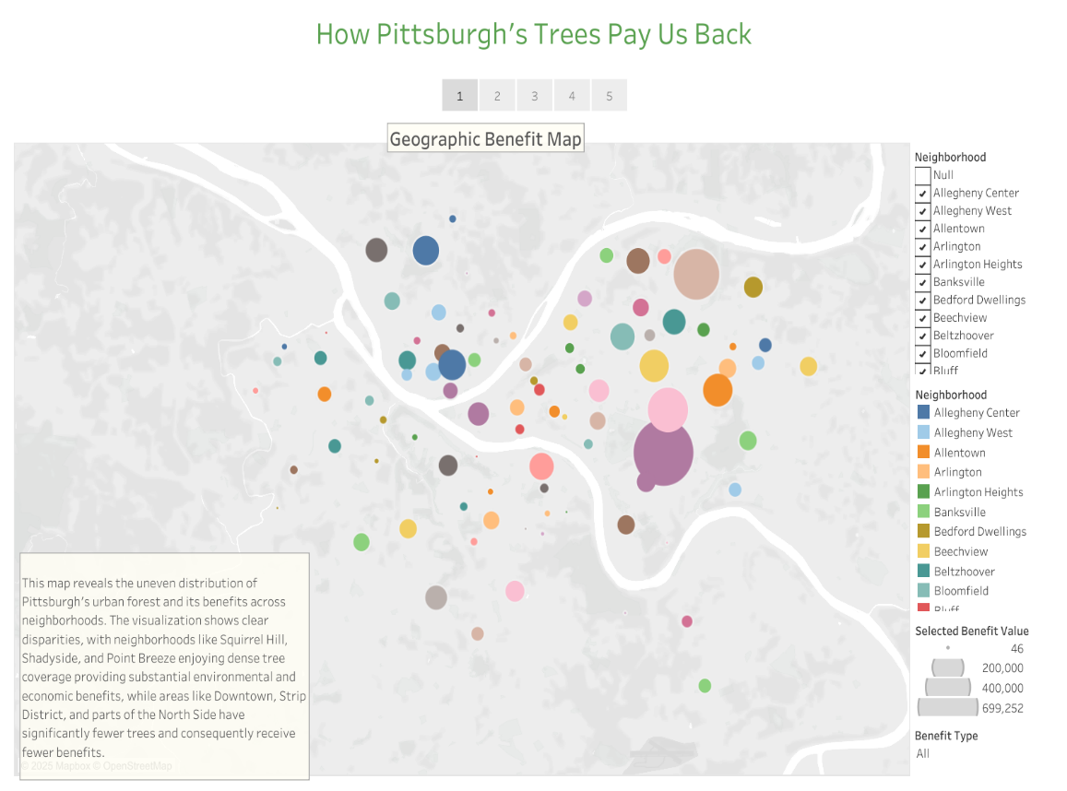
https://public.tableau.com/app/profile/matthew.marzano/viz/DataStoryPittsburghTrees/Story1#1

Visualization 1: Geographic Benefit Map
This map reveals the uneven distribution of Pittsburgh's urban forest and its benefits across neighborhoods. The visualization shows clear disparities, with neighborhoods like Squirrel Hill, Shadyside, and Point Breeze enjoying dense tree coverage providing substantial environmental and economic benefits, while areas like Downtown, Strip District, and parts of the North Side have significantly fewer trees and consequently receive fewer benefits.
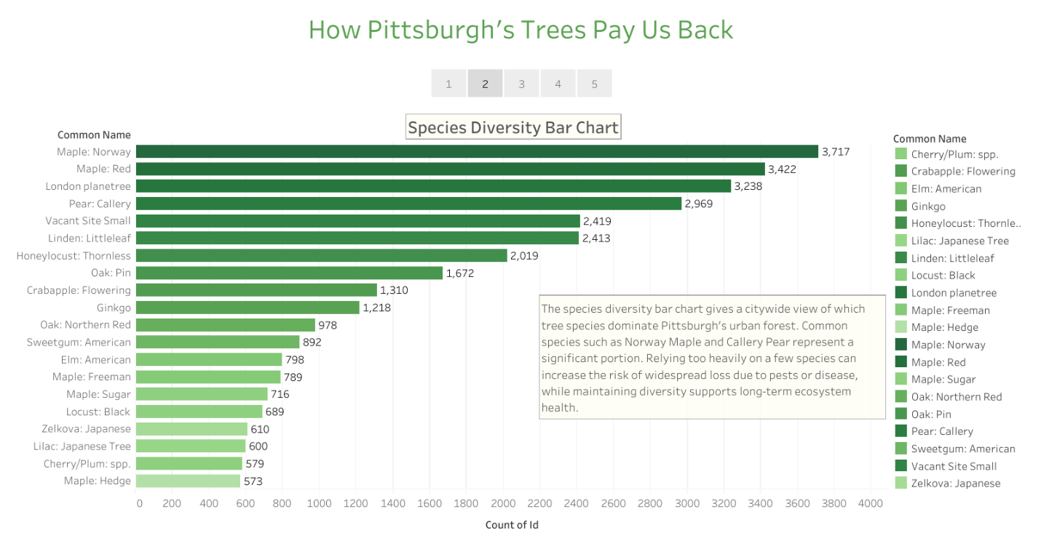
Visualization 2: Species Diversity Bar Chart
The species diversity bar chart gives a citywide view of which tree species dominate Pittsburgh’s urban forest. Common species such as Norway Maple and Callery Pear represent a significant portion. Relying too heavily on a few species can increase the risk of widespread loss due to pests or disease, while maintaining diversity supports long-term ecosystem health.
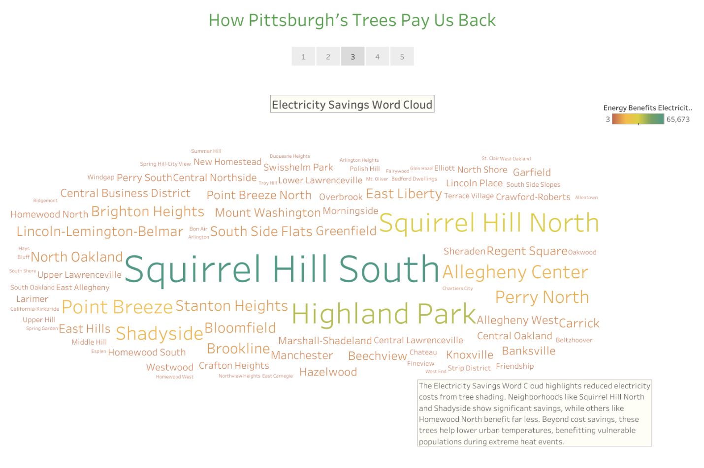
Visualization 3: Electricity Savings Word Cloud
The Electricity Savings Word Cloud highlights reduced electricity costs from tree shading. Neighborhoods like Squirrel Hill North and Shadyside show significant savings, while others like Homewood North benefit far less. Beyond cost savings, these trees help lower urban temperatures, benefitting vulnerable populations during extreme heat events.
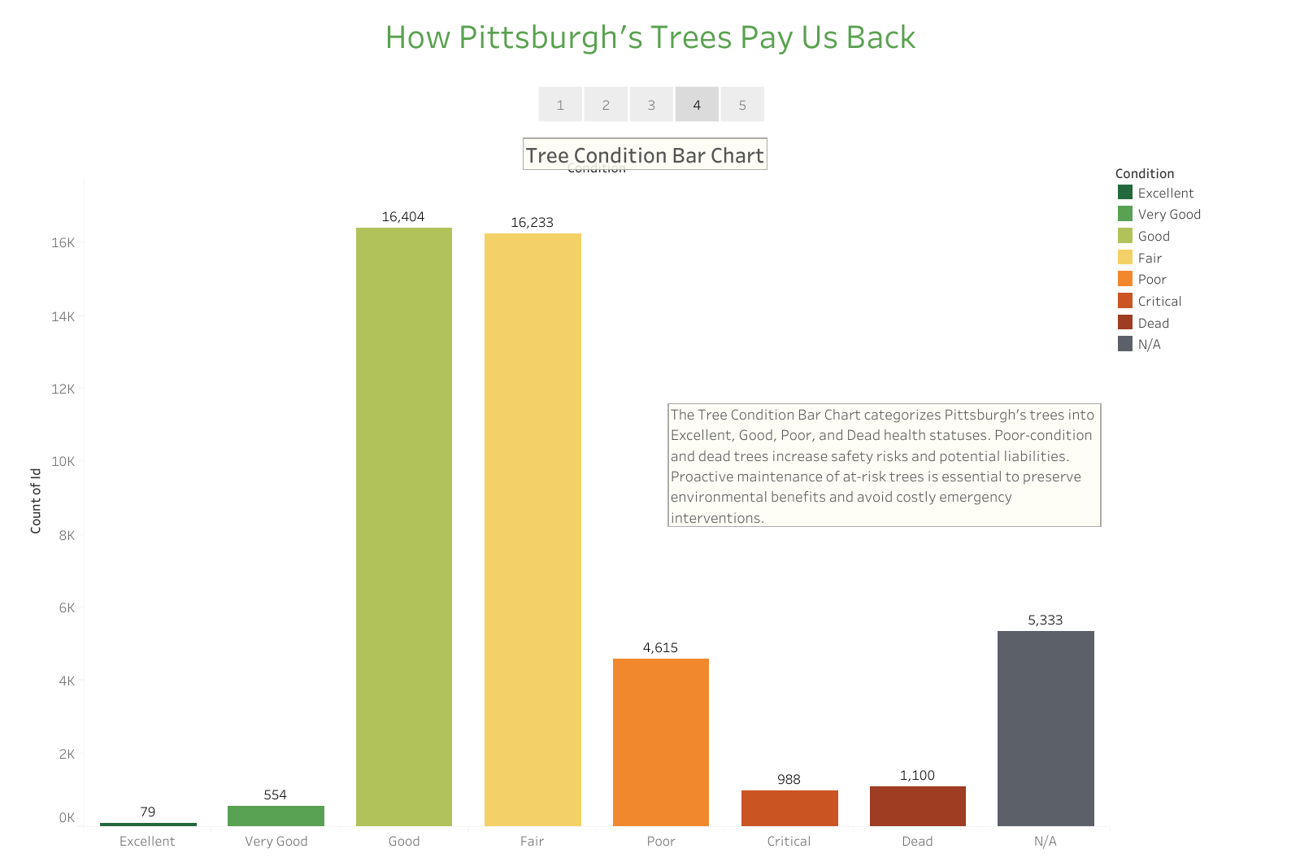
Visualization 4: Tree Condition Bar Chart
The Tree Condition Bar Chart categorizes Pittsburgh’s trees into Excellent, Good, Poor, and Dead health statuses. Poor-condition and dead trees increase safety risks and potential liabilities. Proactive maintenance of at-risk trees is essential to preserve environmental benefits and avoid costly emergency interventions.
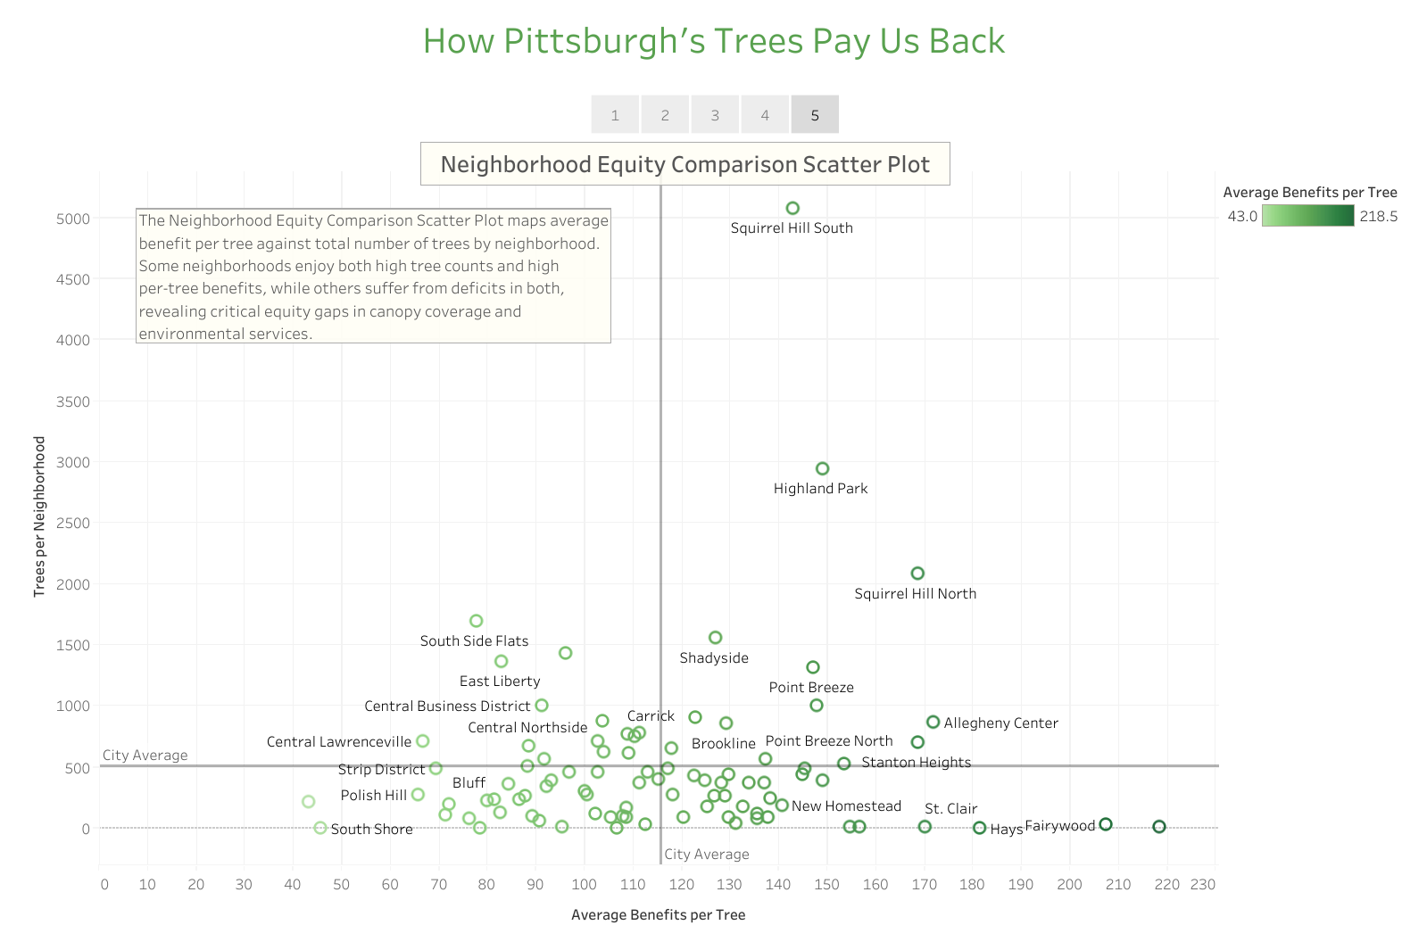
Visualization 5: Neighborhood Equity Comparison Scatter Plot
The Neighborhood Equity Comparison Scatter Plot maps average benefit per tree against total number of trees by neighborhood. Some neighborhoods enjoy both high tree counts and high per-tree benefits, while others suffer from deficits in both, revealing critical equity gaps in canopy coverage and environmental services.

Main Takeaway
Pittsburgh’s urban forest provides significant environmental and economic benefits, but these advantages are unevenly distributed. Through strategic planting, targeted maintenance, and increased species diversity, the city can close canopy gaps and advance environmental justice and climate resilience.

